COMPASS CODAC Sytem

May, 2011

Index

COMPASS CODAC Sytem
Index
System Overview
Main components and connections
FireSignal
Brief description
State machine
MARTe - FireSignal state equivalence
Timing PC
State machine
Connections
MARTe
CKD-MARTe-Timing PC Communications
Offline mode (i.e. between pulses)
Online mode (i.e. from the moment the pulse is submitted by the machine operator)
State machine

System Overview

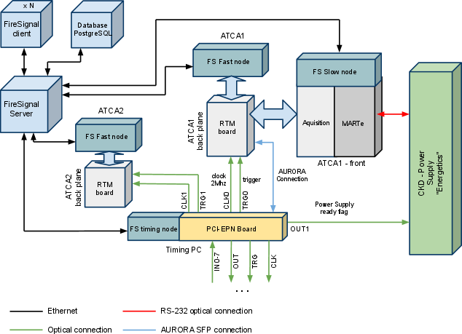
Figure 1: main connections between the various systems present in the COMPASS control and data acquisition system.

Main components and connections

FireSignal

Brief description
FireSignal is the core software of the COMPASS CODAC system and is used to control the experiments (program the triggers via FireSignal timing node and launch the main event) and also to receive data (through the Fast and Slow acquisition nodes). The FireSignal Client is the user interface software module and it is possible to have multiple users connected simultaneously.
The data passes through the FireSignal server and is stored in files that are indexed by a PostgreSQL database. Using some libraries (currently SDAS), the data can be accessed with the most common data analysis tools (IDL, Mathematica, Matlab, Octave, Python).
All FireSignal modules are connected through an ethernet network.

State machine
FireSignal nodes have two main states:
- STOPPED is an idle state between pulses. The machine operator can configure all nodes (triggers, acquisition, MARTe system) or do changes in the experimental setup. It’s possible to use the configuration used in the previous experiment without the need to change or program anything. During the STOPPED state, MARTe is running in Offline mode.
- RUNNING. During this state, MARTe is on Online mode and all systems are prepared for the shot itself. MARTe takes control of the experiment and communicates with “Energetics” and the Timing PC saying when the triggers and clocks can be enabled (this is described later with more detail). The Fast Acquisition nodes are waiting for the trigger to start the acquisition. In this state, the operator may abort the experiment and go directly to STOPPED state without waiting for triggers.
When the nodes receive their clocks and triggers, they control and acquire. After uploading the data to the FireSignal server or finishing the control, they change to STOPPED state.

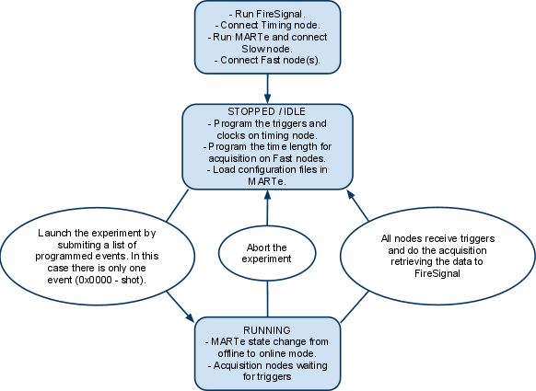
Figure 2: Flowchart of the FireSignal operation

MARTe - FireSignal state equivalence

MARTe | FireSignal
IDLE | STOPPED
WAITING_FOR_PRE | CONFIGURED
PULSING | RUNNING
POST_PULSE
COLLECTION_COMPLETED | STOPPED

Timing PC

State machine
The timing PC is a standard computer, based on an intel x86 processor running a linux distribution.
It’s main function is to generate and distribute the control, trigger and clock signals needed by the control and a data acquisition system. It is connected to MARTe running in the ATCA crate by a full-duplex, 2.5 Gigabit LC connection trough a SFP module. The communication is made trough the AURORA protocol (Xilinx).

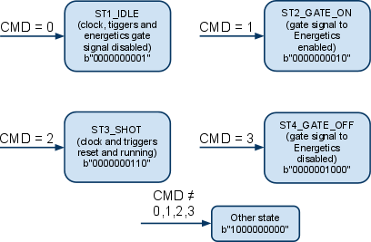
Figure 3

The timing PC has four main states, and the states are controlled by a set of commands (CMD) sent by MARTe through the AURORA connection. The machine is by default in the idle state where all clock signals and triggers are turned off. In the event of a COMPASS shot, it cycles trough three other states, preparing for the shot itself, and to enable the trigger and clock signals during acquisition. There is a fifth state for which the machine goes when it receives an invalid command. The binary word on each state correspond to the values of a set of LEDs defined as the outputs.

Connections
The timing PC has two main type of connections. The first is the full-duplex 2.5 Gigabit AURORA connection to the ATCA 1 crate running MARTe. This connection is made by means of a LC fiber optic cable connected at the back plane of the ATCA crate at one end (on RTM board), and to SFP channel number 0 at the other end. The location of the SFP channel 0 is illustrated in Figure 4.

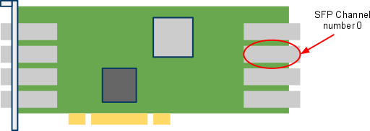
Figure 4: PCI-EPN board installed in Timing PC.

The second type of connections are the general purpose optic transceivers with optic plugs in the front panel of the Timing PC. There are 8 inputs, 8 outputs, 8 clocks and 8 triggers all numbered from 0 to 7, as illustrated in Figure 5. The inputs and outputs are designed to low-level control of the experiment and to depend on the states of the Timing PC. For this reason they are directly programmed in the firmware and the machine operator can’t change the settings for inputs and outputs.
Currently the inputs aren’t being used and only one output channel is used. Output channel number 1 is connected to the energetics power supplies to send the gate_on signal. As we can see on Figure 3, the second significant bit (output channel 1) is active in ST2_GATE_ON and ST3_SHOT states.
Clocks and triggers are programmed by the machine operator in the FireSignal Client software.

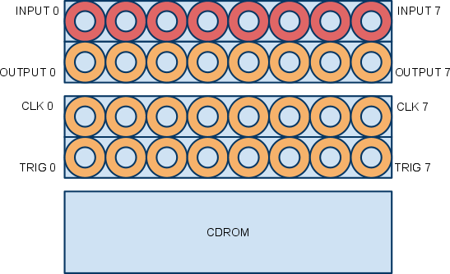
Figure 5: Schematic of the front panel of the Timing PC with the optic plugs.

MARTe
MARTe is a key system in COMPASS tokamak control because it is responsible for the control of the Energetics power supplies and also sends the commands to the Timing PC when the triggers for all diagnostics can be sent. MARTe has two main states. An idle state called offline mode and an active state (Online mode) when all the preparation for the pulse and the pulse itself is done. The operations of MARTe are described and illustrated below.

CKD-MARTe-Timing PC Communications

Offline mode (i.e. between pulses)

- Send an Aurora Reset message (CMD=0) to the timing PC
- If the CKD Energetics is still ON (SSOK status bit ON) send a Stop Operation message to the Energetics
- Each 3 milliseconds ask the Energetics for its status. Each of these commands is sent 1 millisecond apart:
  - Get status
  - Get capacitor bank charge status
  - Get error count

Online mode (i.e. from the moment the pulse is submitted by the machine operator)
- Do these steps alternately while SSOK status bit is not ON, CCPON status bit is not ON and EnergeticsRunOK status bit is not ON (max. 2000 attempts, ~1 second):
  - Send a Get Status command to the Energetics
  - Send a Start Operation command to the Energetics if any the stated bits is not ON
- Keep monitoring TFPSRunOK, MFPSRunOK, EFPSRunOK, SFPSRunOK and TVReady status bits until all of them are ON (usually what takes longer is charging the capacitor but for that there is NO timeout)
- When these status bits are all ON, do these steps until the GATE signal received status bit is ON (max 40000 attempts, ~20 seconds):
  - Send an Aurora GATE On command (CMD=1) to the Timing PC
  - Send a Get Status command to the Energetics
- When the GATE signal received status bit is ON, send an Aurora GATE Received command (CMD=2) to the Timing PC
- During the pulse send these command at each cycle to the Energetics:
  - Set TFPS Setpoint
  - Set MFPS Setpoint
  - Set EFPS Setpoint
  - Set SFPS Setpoint
- After the last point of the TFPS programmed waveform is read do these steps alternately until the SSOK status bit is OFF (max. 2000 attempts, ~1 second):
  - Send a Get Status command to the Energetics
  - Send a Stop Operation command to the Energetics
- Send an Aurora GATE OFF command (CMD=3) to the Timing PC
- If the maximum number of attempts in any of the previously specified items is reached, the communications with the Energetics real-time code goes to an Error state and continuously sends an Aurora GATE OFF command (CMD=3) to the Timing PC.

State machine

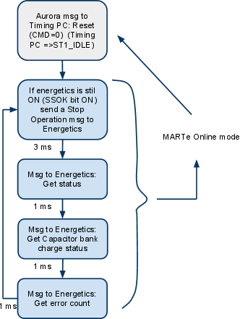
Figure 6: MARTe offline mode fluxogram

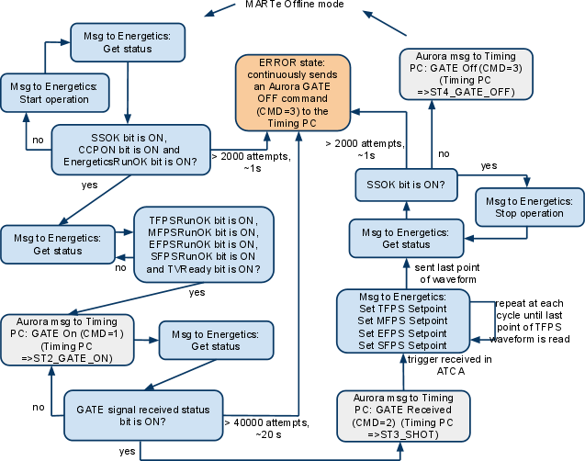
Figure 7: MARTe online mode fluxogram

