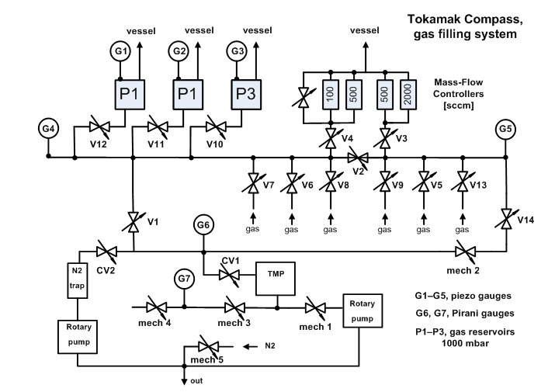
Gas filling stand for COMPASS
(located in the cellar)

- What must be remote controlled and what information about the actual state of the controlled part (and even not controlled, but for the operation important) is to disposal:
- 2 pieces of rotary pumps;
- 1 piece of turbomolecular pump (TMP);
- 13 pieces of electrically controlled (every two wires for solenoid 24V DC/0.2A), but by pressurized air driven valves with electrical signalization of the actual valve position (another two wires: valve is closed – wires are disconnected , valve is open – wires are connected), see CV1, CV2, V1-V9, V13, V14 in the figure below;
- 3 pieces of electrically controlled (7-pins connector, pins 1 and 2 – feeding of solenoid by 24V DC/0.2A), by pressurized air driven valves, with electrical signalization of the actual valve position (valve is open → pins 3 and 4 are connected; moreover the position is visible also by eyes), see V10, V11, V12 in the figure below;
- 4 pieces of Mass-Flow Controllers (controlled voltage 0-5V, connected through 15-pin connector).
Note: In addition, 5 pieces of mechanically handled valves with any position signalization
are also used in the vacuum scheme, see mech1-5 in the figure below.

- The vacuum will measured using 7 vacuum gauges with digital output:
5 pieces of piezo gauges CPT-100 (1-2000mbar)
2 Pirani gauges PPT-100 (10⁻⁴-1000mbar)

Prague, 9.1.2008

